Crisis Prevention & Response Plan 2020-21
Kanawha County School
Garnet Career Center | 304-348-6195 | 304-348-6198 - fax
422 Dickinson Street | Charleston, WV | 25301
Law Enforcement Agency: City of Charleston Police Department |  | Fire Department City of Charleston

CRISIS RESPONSE PLANNING TEAM (CRPT)
Title | Name | Office Phone | Home Phone | Cellular | Email
Principal | Susan Sweat | 304-348-6195 |  | 304-415-4970 | ssweat@mail.kana.k12.wv.us
School Counselor | Janice Standish | 304-348-6195 |  | 304-389-2838 | jstandish@mail.kana.k12.wv.us
School Nurse | Emily Moore | 304-348-6500 |  | 304-415-6792 | eamoore@mail.kana.k12.wv.us
Teacher #1 | Lisa Shiltz lshiltz@mail.kana.k12.wv.us | 304-348-6195 |  | 304-382-1223 | lshiltz@mail.kana.k12.wv.us
Teacher #2 | Teresa Reynolds | 304-348-6195 |  | 304-419-4429 | treynolds@mail.kana.k12.wv.us
Service Person | Gary Kinder | 304-348-6195 |  | 304-533-1455 | gkinder@mail.kana.k12.wv.us
Parent #1 (LPN Student Pres) | To be named in Sept.
Parent #2 (LPN Student VP) | To be named in Sept.
The following are recommended members
County Board Member
School Based Community Mental Health Professional
Comprehensive Behavioral Health Disaster Coordinator
Local Law Enforcement | Charleston Police Dept. | 304-357-0191
Fire/Rescue | Charleston Fire Dept. | 304-357-0191
Local EMA Director |  | 304-357-0191

CRISIS RESPONSE TEAM (CRT)
Title | Name | Office Phone | Home Phone | Cellular | Email
Principal | Susan Sweat | 304-348-6195 |  | 304-415-4970 | ssweat@mail.kana.k12.wv.us
Asst. Principal/Head Teacher | Teresa Reynolds | 304-348-6195 |  | 304-419-4429 | treynolds@mail.kana.k12.wv.us
Head Custodian | Gary Kinder | 304-348-6195 |  | 304-533-1455 | gkinder@mail.kana.k12.wv.us
School Nurse | Emily Moore | 304-348-6500 |  | 304-415-6792 | eamoore@mail.kana.k12.wv.us
School Counselor | Janice Standish | 304-348-6195 |  | 304-389-2838 | jstandish@mail.kana.k12.wv.us
School Resource Officer(SRO)  (if applicable) | n/a
Evacuation Coordinator | Susan Sweat | 304-348-6195 |  | 304-415-4970 | ssweat@mail.kana.12.wv.us
Reunification Coordinator | Lisa Shiltz | 304-348-6195 |  | 304-382-1223 | lshiltz@mail.kana.k12.wv.us

NOTES:
1. For schools with more than one Assistant Principal include all and add as many rows as necessary.
2. For schools that split the student population into more than one Evacuation/Reunification site, there must be a designated Coordinator for EACH site. Add as many rows as necessary.

EVACUATION / REUNIFICATION SITES
- PRIMARY:  First Baptist Church |  | ADDRESS:  432 Shrewsbury Street  Charleston, WV 25301 |  | PHONE:  304-344-4754
ROOMS/AREA LOCATED IN BUILDING: |  | Outside – Near Interstate – Exit school on Shrewsbury St. side of Garnet proceed behind First Baptist Church right on John Norman; left on Leon Sullivan Way- Under Bridge
ADMINISTRATOR(s) IN CHARGE |  | NAME  Susan Sweat |  | PHONE(s) – CELL AND LANDLINE  304-415-5385  304-415-4970  304-348-6195
BUSES NEEDED?  No |  | REGULAR  None |  | SPECIAL BUSES NEEDED  None
If the site is NOT a school (e.g. business, church etc.) complete this row. |  | Did you list this as a Named Insured with BRIM? Yes/No  Students are all adult students and would be dismissed to drive themselves home. |  | Did you create a Memorandum of Understanding (MOU)?  No – Students are all adult students and would be dismissed to drive themselves home.
- SECONDARY: Capitol Market |  | ADDRESS: 800 Smith St, Charleston, WV 25301 |  | PHONE: (304) 344-1905
ROOMS/AREA LOCATED IN BUILDING: |  | Main area inside between WV Marketplace and Soho’s restaurant
ADMINISTRATOR IN CHARGE |  | NAME  Susan sweat |  | PHONE(s) – CELL AND LANDLINE  304-415-5385  304-415-4970  304-348-6195
BUSES NEEDED?  No |  | REGULAR  None |  | SPECIAL BUSES NEEDED  None
If the site is NOT a school (e.g. business, church etc.) complete this row. |  | Did you list this as a Named Insured with BRIM? Yes/No Students are all adult students and would be dismissed to drive themselves home. |  | Did you create a Memorandum of Understanding (MOU)?  No – Students are all adult students and would be dismissed to drive themselves home.
 | EVACUATION / REUNIFICATION SITES (continued)
 | - NON-SCHOOL  None |  | ADDRESS |  | PHONE
 | ROOMS/AREA LOCATED IN BUILDING:
 | ADMINISTRATOR IN CHARGE |  | NAME |  | PHONE(s) – CELL AND LANDLINE
 | BUSES NEEDED? |  | REGULAR |  | SPECIAL BUSES NEEDED
 | Complete this row, as at least one site must not be another school. |  | Did you list this as a Named Insured with BRIM? Yes/No |  | Did you create a Memorandum of Understanding (MOU)?

*A Sample MOU can be found in the Appendix.
**Principals should notify parents of Evacuation/Reunification locations and procedures. A sample Parent Evacuation/Reunification Notice can be found in the Appendix.

SCHOOL SPECIFIC INSTRUCTIONS FOR DRILLS:
FIRE DRILL: The fire alarm will sound and all occupants will exit the building immediately at the closest exit. Teachers are to take the safety bag, walkie-talkie and attendance sheets with them as they exit. They are to close the door and turn off the lights. The teachers move to the designated area away from the building. They are to take class attendance and notify the secretary and/or principal who is in the front away from the building if there are any problems. Instructors and students will be notified by walkie-talkie when all clear is determined.
BOMB THREAT: Listen to the caller and remember/write down specific threat details. Do not immediately evacuate.
Call 911. Call Central Office. Call Keith Vititoe. Assess threat. Search the interior and exterior of the building. Have teachers assess their rooms and check for suspicious items. Do not do anything without the principal’s direction.
SHELTER IN PLACE: Upon receipt of a message requiring a shelter-in-place, all individuals located inside the building shall proceed to the pre-designated area which is the first floor hallway, unless otherwise directed. If an individual experiences difficulty, an instructor shall attempt to move them to the shelter area. The secondary shelter areas may be designated if the need arises. Once in shelter area, all persons must be accounted for and reported to the command post. Administration will conduct roll call at this time. All windows shall be shut and air conditioners shall be turned off. All doors and vents leading to the designated shelter area shall be taped. Contact will be made with the local emergency office as soon as possible. Everyone shall remain in the designated area until an “all clear” signal is given or evacuation vehicles arrive at the front door.
PRECAUTIONARY LOCKDOWN: If there is no immediate threat but the school has to be locked down, the principal will notify building occupants by intercom of the situation. It will be stated it is a “precautionary lockdown” as a preventative measure to safeguard the school. The lockdown button will be pushed; staff will account for all students in their classrooms with doors locked and dead bolted if available; no one will be allowed in the hallways; close all curtains and blinds; cover exposed windows and doors; no one will be permitted in or out of the building; staff will standby for further orders and be prepared to barricade or evacuate; principal will call the superintendent’s office and or the security director’s office.
LOCKDOWN: Notification of a lockdown may come from the intercom, telephone, text message or audible signs of gunfire to lockdown the classrooms and office. If there is an imminent threat, the message will state “Lockdown! Lockdown! There is an intruder…” and will continue with as much information as possible. If a staff member hears gunfire or sees someone with a weapon they do not have to wait for an official “lockdown” message. The following steps will be taken: principal will push the lockdown button to lock exterior doors; all personnel will react immediately by determining to lockdown/barricade in classrooms or evacuate dependent on information received from the principal/command area; lockdown in classrooms includes closing curtains and blinds, turn off lights, stay away from windows and doors, stay quiet, use heavy belts to tie off doors, use furniture to barricade doors; be prepared for breaches of barricades by countering the intruder with noise, distraction, movement, objects to overwhelm the intruder; separate all weapons from intruder; obey all commands from the police ; evacuate with hands up and palms facing away; lockdown is maintained until the principal declares an “all clear” (over the intercom, telephone, text) or the police arrive to escort everyone out of the building.
ACTIVE SHOOTER/ARMED INTRUDER: If staff hears gunfire or sees someone with a weapon they do not have to wait for an intercom message to react – start emergency procedures immediately. Those rooms in close proximity to the threat will lockdown and barricade. Windows and doors will be covered to obstruct the view from outside the room. Those personnel in rooms on the other end of the building that have a safe route out will assess the situation and may make their own decision whether to evacuate or stay. If they do not leave they must barricade their door. Be prepared to exit through ground floor windows if necessary. As a last resort if the situation warrants, throw anything at the intruder to distract them. Be prepared to immediately swarm him/her to disarm them. Each staff or student swarming the intruder should grab one limb and then use bodyweight to drag the intruder down to the floor. Continue to restrain the intruder until the police arrives. Do not pick the weapon up! Place a trashcan over the weapon and guard it until the police arrives.

WV School Mental Health Crisis Team Planning Template
School:____Garnet Career Center _______________ Team Manager_____Susan Sweat, Principal__________________________
Contact Phone____304-348-6195_______________ Contact Email_____ssweat@mail.kana.k12.wv.us_____________
SCHOOL MENTAL HEALTH CRISIS PLANNING TEAM (SMHCPT)
Identify team members - Suggested roles on left
Title | Name | Office Phone | Home Phone | Cellular | Email
School Counselor | Janice Standish | 304-348-6195 |  | 304-389-2838 | jstandish@mail.kana.k12.wv.us
Principal | Susan Sweat | 304-348-6195 |  | 304-415-4970 | ssweat@mail.kana.k12.wv.us
School Nurse | Emily Moore | 304-348-6500 |  | 304-415-6792 | eamoore@mail.kana.k12.wv.us
School-based Mental Health Provider | Belinda Chafin | 304-348-6195 |  | 304-369-3736 | bchafin@mail.kana.k12.wv.us
Community Mental Health Provider | Prestera Center | 304-344-0511  304-414-3075 |  |  | Lisa Zappia, Clinical Director  Prestera  304-525-7851  877-399-7776  Barri.faucett@prestera.org
Prevention Resource Officer | n/a
Special Educator | n/a
Student (LPN Student Pres) | TBD in September
Teacher | Teresa Reynolds | 304-348-6195 |  | 304-419-4429 | treynolds@mail.kana.k12.wv.us
Parent (LPN Student VP) | TBD in September
Other
Other

SCHOOL MENTAL HEALTH CRISIS TEAM (SMHCT)
In ADDITION to your School Mental Health Crisis Planning Team, list additional persons who will assist with response and recovery.
Title | Name | Office Phone | Home Phone | Cellular | Email
School Counselors (from other schools) | Jon Duffy  Lisa Johnson | 304-348-7720  304-348-6544 |  | 304-415-6228  304-546-8292 | jmduffy@mail.kana.k12.wv.us  ejohnson@mail.kana.k12.wv.us
Social Workers | Eddie Ivy | 304-348-1343 |  |  | eivy@mail.kana.k12.wv.us
District leaders
Community Mental Health Representatives | Prestera Center | 304-344-0511 |  |  | Lisa Zappia, Clinical Director  Prestera  304-525-7851  877-399-7776  Barri.faucett@prestera.org
Faith Based Representatives | Salvation Army | 304-343-4548
School Counselors
Others? E.g. Suicide Prevention Center, RESA or WVDE | Suicide Prevention  Prestera Center | 800-273-8255  304-414-3070

Define Purpose and Goals of the MHCPT
What is the purpose of the MHCPT? | To ensure the adult students of Garnet Career Center have a safe and healthy environment in which to attain their chosen professional and career goals.
What are the goals of the MHCPT?
To educate the students about suicide prevention/post-vention. For example, address both Jaimee’s Law and the Jason Flatt ACT.

To increase student awareness of the danger and consequences of sexting and social media (legal, emotional, future admission to college, queries by prospective employers, etc.) through online resources and other materials provided by KCS.
Substance abuse prevention – LPN students will discuss these issues during pharmacology/medications classes; Automotive and Business during their preparation for OJT.
Violence –issues of domestic abuse; how it affects the victim at home, school, and work
Mental Health Management – staff will have the resources to identify possible mental health issues of students and have resources for referral.
Medical Health Management – Students will provide a medical/emergency card/form during orientation of their program. This card/form will be kept current throughout their tenure. Medications and other procedures may need to be reviewed with administration.
For crises that cannot be prevented, our team will implement recovery plans that support students and provide a safe learning environment that will allow for students to maintain or improve upon their academic success. (no dramatic grade drops after an incident or withdrawal from programs)
How often will the MHCPT meet? | Two to four times a year, during Professional Development time or after Faculty Senate meetings, as needed.
Who will record and distribute meeting Notes? | The school counselor or safety committee secretary will be responsible for recording the meetings and distributing the notes to the members.
Crisis Prevention and Response Plan to Address Mental Health Needs by Incident Type
(Refer to Resources in the Appendices of the Addressing Mental Health: A Guide for WV Schools)
SUICIDE PREVENTION
Note: Our students are adults, however, these resources can be beneficial to them.
Resources/Programs |  | Action Steps | Person(s) Responsible
Prevent Suicide WV  www.preventsuicidewv.org  Suicide Prevention Lifeline… https://suicidepreventionlifeline.org  www.crisistextline.org  www.sprc.org  www.Help4WV.com  Preventing Suicide: Toolkit for High School  https://store.samhsa.gov/shin/content/SMA12-4669/SMA12-4669.pdf  After A Suicide: Toolkit for Schools  www.sprc.org/sites/default/files/library/AfteraSuicideToolkitforSchools.pdf |  | Protocols as outlined in “Preventing Suicide a Toolkit for High Schools”  - Establishing protocols for helping students at risk for suicide  - Establish protocols for responding to suicide death  - Staff / Parent Education and Trainings:  - ASAP-20  - QPR: Question Persuade Refer  - RRR: Recognize, Respond, React  - More Than Sad  - Lifeline Postvention  - SafeTALK  - ASIST  - Parent/Guardian Outreach  - Student Education:  - More Than Sad  - SOS  - Lifeline  - Good Behavior Game  - Student Screening:  - PHQ-9  - Columbia  - ASAP-20 | Prevent Suicide WV / ASPEN  Lisa Zappia, Clinical Director  Prestera  304-525-7851  877-399-7776  Barri Faucett  Barri.faucett@prestera.org’

SUICIDE RESPONSE
Resources/Programs | Action Steps |  | Person(s) Responsible
SUICIDE ATTEMPT SURVIVOR PACKET  - After an Attempt (brochures for self & family) www.samhsa.gov  - Journey Toward Health & Hope https://store.samhsa.gov/shin/content/SMA15-4419/SMA15-4419.PDF  - Means Matter: Recommendations for Families  www.hsph.harvard.edu/means-matter/ | CRISIS RESPONSE TEAM LEADER CHECKLIST  - Inform the school superintendent of the death.  - Contact the deceased’s family to offer condolences, inquire what the school can do to assist, discuss what students should be told, and inquire about funeral arrangements.  - Call an immediate meeting of the Crisis Response Team to assign responsibilities.  - Establish a plan to immediately notify faculty and staff of the death via the school’s crisis alert system (usually phone or e-mail).  - Schedule an initial all-staff meeting as soon as possible (ideally before school starts in the morning).  - Arrange for students to be notified of the death in small groups (NOT by overhead announcement or in a large assembly) AND disseminate a death notification statement for students to teachers, advisors, or others leading those groups.  - Disseminate handouts on Facts About Suicide and Mental Disorders in Adolescents and Talking About Suicide to faculty.  - Speak with school superintendent and Crisis Response Team Coordinator throughout the day.  - Determine whether additional grief counselors, crisis responders, or other resources may be needed from outside the school.  TEAM COORDINATOR’S CHECKLIST  The tasks below may be delegated as appropriate to specific staff or faculty in the school.  - Conduct initial all-staff meeting.  - Conduct periodic meetings for the Crisis Response Team members.  - Monitor activities throughout school, making sure teachers, staff, and Crisis Response Team members have adequate support and resources.  - Assign roles and responsibilities to Crisis Response Team members in the areas of Safety, Operations, Community Liaisons, Funeral, Media Relations, and Social Media.  SAFETY  - Keep to regular school hours.  - Ensure that students follow established dismissal procedures.  - Call on school resource officers or plant manager to anyone who may show up at the school and to keep media off of school grounds.  - Pay attention to students who are having particular difficulty, including those who may be congregating in hallways and bathrooms, and encourage them to talk with counselors or other appropriate school personnel. |  | Lisa Zappia, Clinical Director  Prestera  304-525-7851  877-399-7776  Barri Faucett  Barri.faucett@prestera.org’
SUICIDE RECOVERY
Resources/Programs |  | Action Steps |  | Person(s) Responsible
See next page: |  | LIFELINE POSTVENTION ROLES  Students  - Receive limited information about the death  - Receive guidance for responding to rumors  - Have designated places for personal reflection  - Receive reminders about their role in the competent community  - Vulnerable students are identified and receive help  - Receive information about school, community and web-based resources  - Be prepared for funeral attendance  Student Screening  - Safety Plan  - Means Restriction Education  - Mental Health and other resource referral |  | Prevent Suicide WV / ASPEN  Lisa Zappia, Clinical Director  Prestera  304-525-7851  877-399-7776  Barri Faucett  Barri.faucett@prestera.org

SAMPLE Recovery Resources
School Postvention Packet  - After a Suicide School Toolkit  - Guidelines for Memorialization  - Lifelines Quick Reference Guide  - Talking Points for Students & Staff  - Preventing Suicide: High School Toolkit  Survivor of Suicide Loss Packet  - After a Suicide, AFSP  - Surviving After a Suicide, AAS  - Organizations and Websites for Survivors  Alliance of Hope for Suicide Survivors  http://www.allianceofhope.org  Friends for Survival  http://www.friendsforsurvival.org  HEARTBEAT: Grief Support Following Suicide  http://heartbeatsurvivorsaftersuicide.org  Parents of Suicides and Friends & Families of Suicides (POS-FFOS)  http://www.pos-ffos.com  Suicide: Finding Hope  http://www.suicidefindinghope.com  KEY SUICIDE PREVENTION ORGANIZATIONS WITH INFORMATION FOR SURVIVORS  American Association of Suicidology (AAS)  http://www.suicidology.org  Suicide Loss Survivors  http://www.suicidology.org/suicide-survivors  American Foundation for Suicide Prevention (AFSP)  http://www.afsp.org  Coping with Suicide  http://www.afsp.org/survivingsuicideloss |  | Suicide Awareness Voices of Education (SAVE)  Coping with Loss  http://www.save.org/coping  Suicide Prevention Resource Center (SPRC)  http://www.sprc.org  KEY GUIDES FOR SURVIVORS  After a Suicide: Recommendations for Religious Services and Other Public Memorial Observances  http://www.sprc.org/sites/sprc.org/files/library/aftersuicide.pdf  SOS: A Handbook for Survivors of Suicide  http://www.suicidology.org/c/document_library/get_file?folderId=229&name=DLFE-73.pdf  Available in Spanish at: http://www.suicidology.org/c/document_library/get_file?folderId=259&name=DLFE-782.pdf  Suicide: Coping with the Loss of a Friend or Loved One  http://www.save.org/index.cfm?fuseaction=shop.productDetails&product_id=548F7ABC-A30B-FA7B-3375C27BCFB5A265  Surviving a Suicide Loss: A Financial Guide  https://www.afsp.org/coping-with-suicide/resources/a-financial-guide  Surviving a Suicide Loss: A Resource and Healing Guide  https://www.afsp.org/coping-with-suicide/where-do-i-begin/resource-and-healing-guide  Survivor of Suicide Loss Resources  http://www.sprc.org/search/library/Survivors%20of%20Suicide%20Loss?filters=type%3Alibrary_resource
BULLYING, HARASSMENT AND CYBER-BULLYING
Resources/Programs | Action Steps |  | Person(s) Responsible
Safe Schools Online Training | Complete Training in these areas. |  | All instructors, principal, counselor
Student Code Of Conduct/Garnet Career Center Handbook | Students will read and sign off on Garnet Career Center Handbook |  | All instructors & All Students
WV Hate Crime Task Force | 888-676-5546 – Report action if needed after in-house steps are taken based on KCS Policy C53 |  | Principal, counselor
SEXTING
Resources/Programs | Action Steps |  | Person(s) Responsible
Adolescent Health Initiative  Child/Abuse Hotline -- WVDHHR | KCS Policy J33A – Telecommunications Network Access |  | Principal, Counselor
 | KCS Policy J25 – Student Code of Conduct |  | Principal, Counselor
SUBSTANCE ABUSE
Resources/Programs | Action Steps |  | Person(s) Responsible
Safe Schools Online Program | KCS Policy J25 – Student Code of Conduct |  | Principal, Counselor
Student Code Of Conduct/Garnet Career Center Handbook | Students will read and sign off on Garnet Career Center Handbook |  | All instructors & All Students
Prestera Center | Identify issues; recommend help |  | Lisa Zappia, Clinical Director  Prestera  304-525-7851  877-399-7776  Barri.faucett@prestera.org
Kanawha County CTC Substance Abuse |  |  | Agency Director – 304-437-3356
VIOLENCE (Sexual Assault, Domestic Violence, Fighting, Weapons, Gangs, Homicide, Etc.)
Resources/Programs | Action Steps |  | Person(s) Responsible
Safe Schools Online Training | KCS Policy J25 – Student Code of Conduct |  | Principal, Counselor
Student Code Of Conduct/Garnet Career Center Handbook | Students will read and sign off on Garnet Career Center Handbook |  | All instructors & All Students
Rape/Sexual Assault Services | Refer to Domestic Violence Services Agencies |  | Principal, Counselor  304-340-3676
YWCA Resolve Family Abuse/Court Advocacy | Refer to Domestic Violence Services Agencies |  | Principal, Counselor  304-340-3549 & 304-610-1575
MENTAL HEALTH MANAGEMENT
(Relationships; effective SAT team; safe, supportive school culture; supporting vulnerable students;
see also Safe Supportive School Plan)
Resources/Programs | Action Steps |  | Person(s) Responsible
Various agencies available in the Kanawha County area:  Addressing special needs/situations  - Kinship care  - Foster care  - Homelessness  - Loss/grief  - Trauma  - LGBTQ  - Emotional/Behavior Disorders  - Depression  - Self-Harm | Refer to Quick Guide to Kanawha County Community Services  Students are provided this list courtesy of the United Way of Charleston |  | Principal, Counselor, School Nurse
MEDICAL HEALTH MANAGEMENT
Resources/Programs | Action Steps |  | Person(s) Responsible
CAMC Resource Center – 304-388-2545  FamilyCare – 304-720-4466  WV Health Right – 304-343-7000  Upper Kanawha Valley Medical Center  304-595-3282  Prestera Center – 304-341-0511 | Refer to Quick Guide to Kanawha County Community Services  Students are provided this list courtesy of the United Way of Charleston |  | School Nurse, Principal, Counselor
SUDDEN DEATH
Resources/Programs | Action Steps |  | Person(s) Responsible
See Resources above for Medical Health | See Action Steps in Medical Health Management |  | Principal, School Nurse, Counselor
FIRE
Resources/Programs | Action Steps |  | Person(s) Responsible
Charleston Fire Department | Drills |  | Principal
FLOOD/DISASTER
Resources/Programs | Action Steps |  | Person(s) Responsible
Charleston Fire Department | Drills to prepare; follow Emergency Services directions |  | Principal
Kanawha County Sheriff Department | Drills to prepare; follow Emergency Services directions |  | Principal
Charleston Police Department | Drills to prepare; follow Emergency Services directions |  | Principal

OTHER
(Insert rows to include additional crises. Ex. homicidal ideation, deployment)
Resources/Programs | Action Steps | Person(s) Responsible
Sample deployment resource
Family Assistance WVARNG
http://www.wv.ngb.army.mil/contact.aspx
HOW WILL YOU EVALUATE THE SUCCESS OF YOUR CRISIS PLAN?
At the end of the school year, the crisis team will reflect on any issues which may have arrived during the year and the responses for each issue.
The Crisis team will review all goals set for the year to evaluate if they were met. If there were goals not met, identify the issues which may have caused the goal unmet.
Comparisons may include school data such as disciplinary data, attendance and academic performance.
HOW WILL YOU ANNUALLY UPDATE YOUR MENTAL HEALTH CRISIS PLAN INCLUDING ENGAGING STUDENTS, STAFF, VOLUNTEERS AND FAMILIES?
At the end of the school year, the crisis team will meet to evaluate the goals set for that year. The following questions will be asked:
Were the goals met?
If not met, why not and how can they be met in the future?
Were there issues that arose that our goals did not predict or foresee? Should a goal be set for the upcoming year for this issue?
Were staff trained to handle any and all issues that may have arisen during the year?

COMMUNICATION PLAN
School Mental Health Crisis Team
How will you activate and communicate with your SCHOOL MENTAL HEALTH CRISIS RESPONSE TEAM?
The response team will be activated as needed through emails and text messages.
DURING THE YEAR, NOT RELATED TO AN INCIDENT
- Who is working toward achieving the goals you established? The crisis team will work together during set times on Faculty Senate days to work toward achieving the established goals for the school year.
- Are additions/modifications to the plan considered after attending conferences where new resources, techniques or programs have been introduced that may be helpful to your school in reaching stated goals? Any new resources brought to the attention of the crisis team will be evaluated and added if applicable to the SMHCT plan.

DURING AN INCIDENT
- Who activates the SMHCRT? The principal or school counselor.
- How is the SMHCRT activated? An email or text message will be sent to all members of the team.
- What is the chain of command? Principal, school counselor, Head Teacher, LPN Coordinator, Reunification Coordinator
- What mode/method of communication is used to inform the chain of command? (text, phone, email, other) Email, text, interschool phone as needed
- Who decides there is a need for additional resources and these needs are being communicated to the Incident Commander (usually the Principal)? Any member of the team may decide if additional resources are needed. These resources will be communicated to the principal and other members either at a scheduled meeting or at an emergency meeting if needed.

DURING RECOVERY, AFTER AN INCIDENT
- Who/how is it determined if additional resources are needed and who to contact from the expanded SMHCRT members/resources? Principal and school counselor may determine if additional resources are needed.
- Who/how is it determined when the school has reached recovery after an incident? The principal and school counselor will evaluate the school environment. Additional help may be requested of the head counselor for KCS.
- Who decides there is a need for additional resources and these needs are being communicated to the Incident Commander (usually the Principal)? Any team member may decide there is a need for additional resources. Other faculty and staff may also communicate such needs if they feel it necessary.

How will you share your plan and ensure all stakeholders know what to expect during each phase of a crisis?
STAFF
A report from the Crisis Team will be given at each Faculty Senate meeting.
STUDENTS
Appropriate information disseminated to students may be communicated through the school newsletter and the school web site. There may also be a school assembly if needed. Students will receive the Campus Safety and Security report by October 1st of each school year. This report is located at the following web address:
Campus Crime Report 2020-21:
Campus Safety and Security Website
https://ope.ed.gov/campussafety/#/institution/details
and will be available to each student through their program instructors.

FAMILIES and COMMUNITY
Appropriate information disseminated to community members may be communicated through the school newsletter and the school web site.

OTHER EMERGENCY CONTACTS
Board of Education |  |  | Local Government Agencies
Main Number | (304) 348-7770 |  | City Government - Charleston | (304) 348-8015
Public Information Officer | (304) 348-7770 |  | County Government | (304) 357-0101
Maintenance | (304) 348-6628 |  | Health Department | (304) 344-5243
Transportation | (304) 348-6616 |  | Emergency Management Agency | (304) 348-8130
Evacuation Sites |  |  | Health & Human Resources Office | 800-642-8589
First Baptist Church -- Primary | (304) 344-4754 |  | County Humane Society | (304) 342-1576
Capitol Market | (304) 344-1905 |  | Comp Behavioral Health Disaster Coordin | (304)
Law Enforcement |  |  | OR | (800)
Police Department | (304) 348-8111 |  | State Government Agencies
County Sheriff’s Office | (304) 357-0191 |  | Division of Highways | (304) 558-3005
West Virginia State Police | (304) 558-7777 |  | Department of Natural Resources (DNR) | (304) 558-3315
First Responders |  |  | WV Bureau for Behavioral Health Disaster Coordination | (304) 356-4788
County EMS | (304) 357-0191
Fire Department | (304) 357-0191 |  | Other
 |  |  | Railroad – Amtrak  CSX | (304) 342-6766  (304) 755-2574
Mental Health Provider |  |  | American Red Cross | (304) 340-3657
Local Mental Health Provider – Prestera | (304) 344-0511 |  | National Weather Service | (304) 746-0180
Utilities |  |  | Poison Control Center | (800) 222-1222
Natural Gas Provider | 800-834-2070 |  | Disaster Hotline | (866) 867-8290
Electric Provider | (304) 346-0456 |  | Suicide Hotline | (800) 273-8255
Water/Sewage Provider | (304) 744-6843
Phone Service Provider | 800-921-8101
Internet (ISP) | (304) 348-7770

STAFF OR FACULTY WITH MEDICAL OR MENTAL HEALTH TRAINING
 | Name | Title | Certification | Expiration Date
 | Teresa Reynolds | PN Prgm Coordinator | RN | Oct 31st of each year
 | Lisa D. Shiltz | PN Instructor | RN | Oct 31st of each year
 | Angel Webb | PN Instructor | RN | Oct 31st of each year
 | Jennifer Toney | PN Instructor | RN | Oct 31st of each year
 | Erica Collins | PN Instructor | RN | Oct 31st of each year
 | Amber Chafin | PN Instructor | RN | Oct 31st of each year
 | Belinda Chafin | PN Instructor | RN | Oct 31st of each year
 | Caren Campbell | Medical Assisting Instructor | CCMA | July 19th every 2 years (2021)
 | Janice Standish | Adult/School Counselor | Professional Student Support Certificate for School Counselor | N/A

INSERT STUDENT SPECIFIC PLANNING (See Appendix Sections A-5 and A-6)
Garnet Career Center

is an adult only facility and does not have students with IEP’s or 504 plans. We also do not have students with the following:

Mobility issues
Respiratory issues
Major medical needs
Autism
Cognitive Developmental issues
Vision impairments
Service Animals
Hearing Impairments
Speech Impairments

INSERT CURRENT SCHOOL FLOORPLANS, EVACUATION ROUTES AND FUEL STORAGE (See Appendix Section A-11) (See attached)
INSERT COPIES OF MEMORANDUMS OF UNDERSTANDING (MOU) FOR NON-SCHOOL EVACUATION SITES(See Appendix Section A-3) (N/A)
INSERT COPY OF FIRE MARSHAL SCHOOL FIRE EXIT DRILL SAFETY REPORT (See Appendix Sections A-7 and A-8) (See attached)
INSERT DRILL AND INCIDENT REVIEW REPORTS (See Appendix Sections A-9) (See attached)

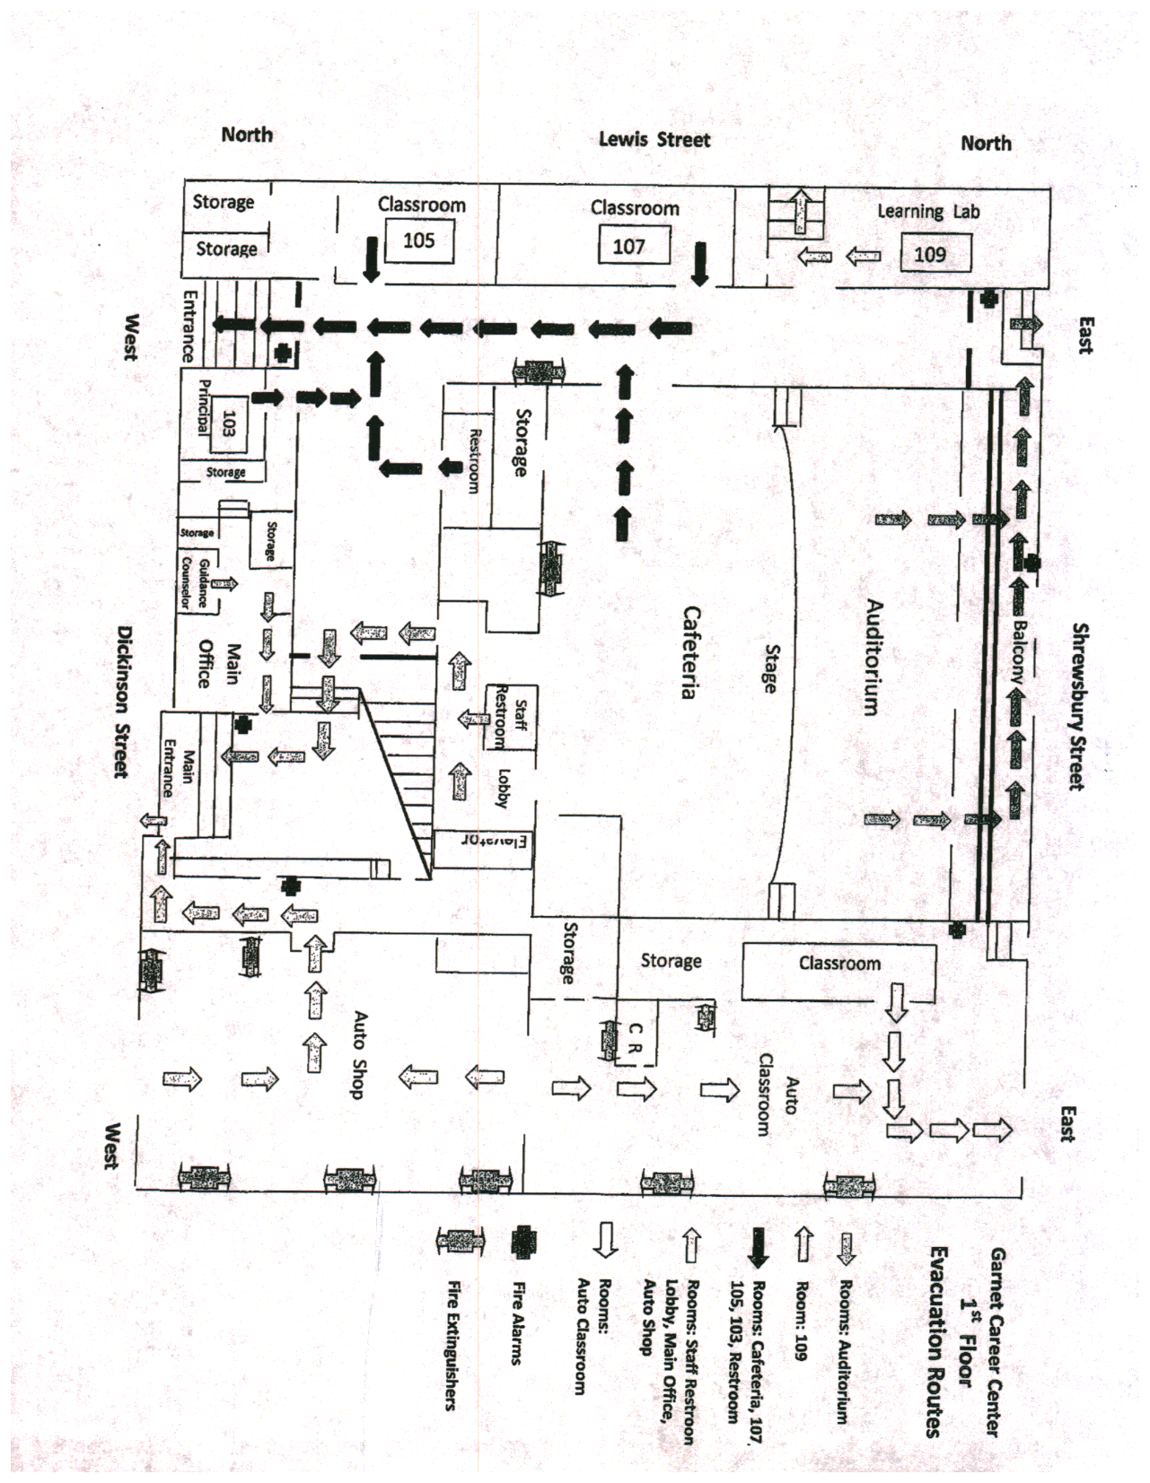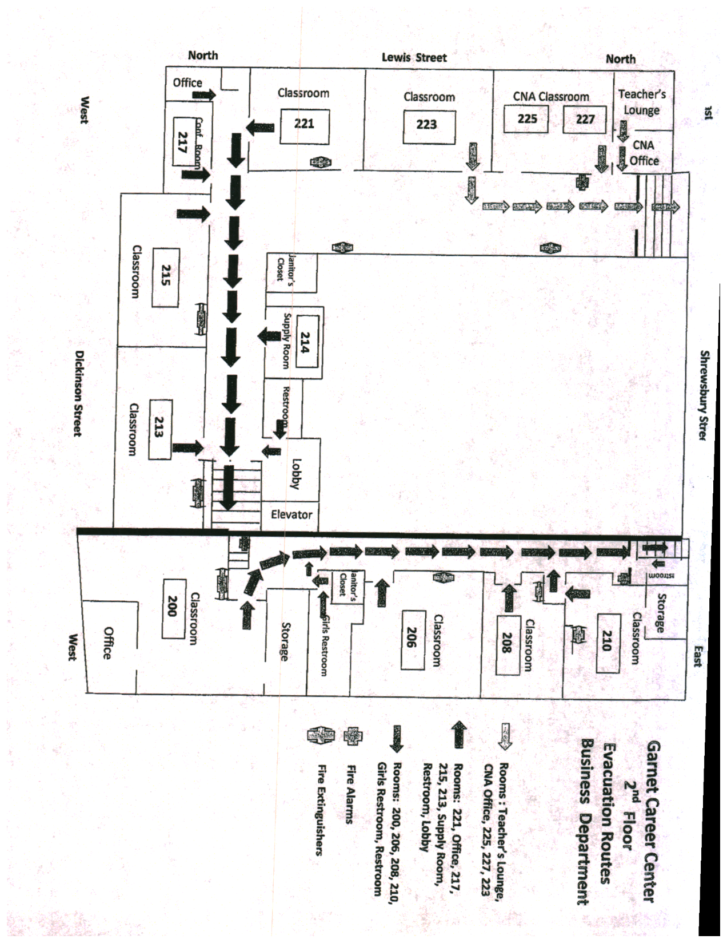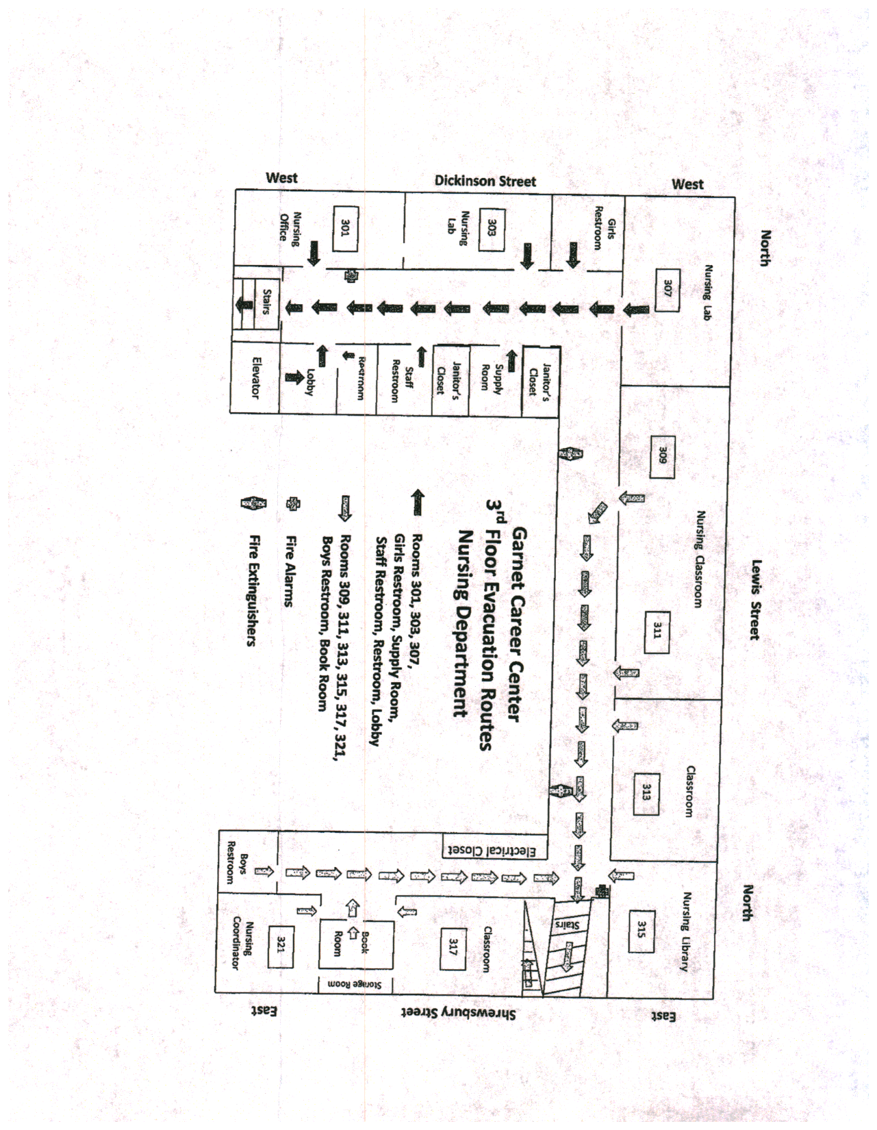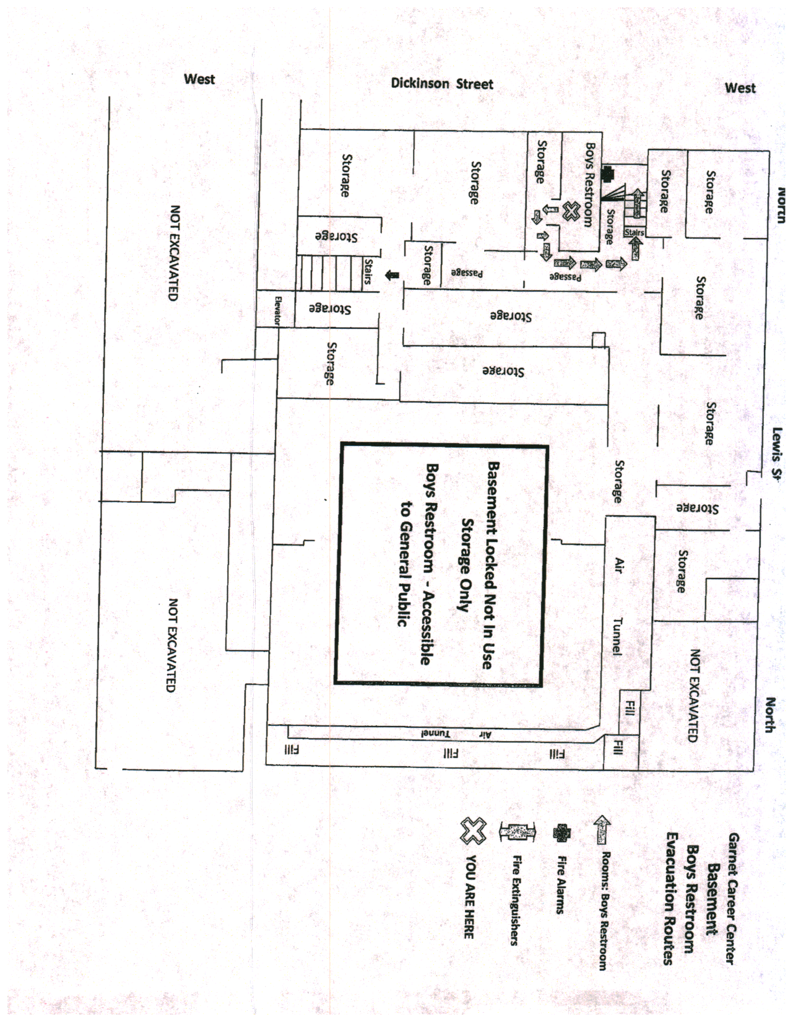
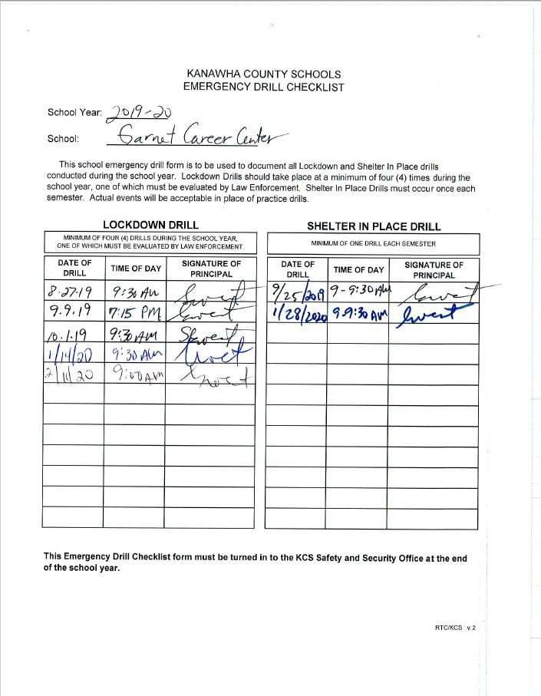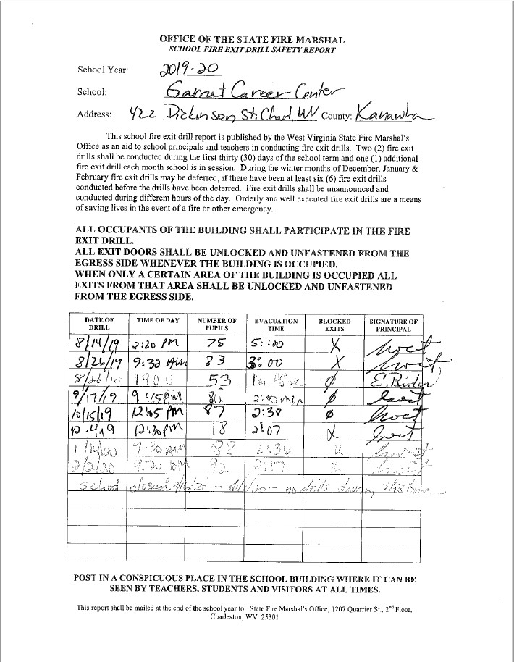
Addendum A: Garnet Career Center COVID -19 Protocols and Procedures

Garnet Career Center follows the WVDE and KCS policies and procedures for COVID-19 policies.
https://wvde.us/covid19/
https://kcs.kana.k12.wv.us/news/latest_news/k_c_s_coronavirus_updates__school_re-_entry
In addition Garnet Career Center has instituted these school specific policies and protocols:
Garnet Career Center COVID-19 Protocols 2020-21
The mission of Kanawha County Schools is to provide a world-class education that ensures success for every student in the 21st Century.
The following is the list of Covid-19 protocols at Garnet Career Center:
- Garnet Career Center (GCC) follows KCS and WVDE policies and the KCS calendar in regard to school breaks and closures.
- All students will have temperature checked by staff upon entering the building. Any student with temperature over 100.4° will not be admitted to the school. Students will consult instructor or program coordinator for instructions on class attendance expectations.
- Students will follow the schedules provided for them by each program, instructor/department chair. Staggered days and times if required by state, local or county mandates will ensure that building retains social distancing requirements. Students will follow designated break times if allowed by and as established by each program. Students will not be allowed in and out of classrooms and/or the building. Only designated break times will be allowed.
- Students will maintain social distancing when entering and leaving the building.
- All students will use hand sanitizer available on table at the main entrance upon entering building and at various stations throughout the building on each floor.
- Garnet students who do not wear/bring their own mask will be provided one by main office upon request. Adult Ed and TASC students will receive masks if needed from those programs.
- Auto students will enter and leave building through Auto Shop garage doors.
- Practical Nursing students will proceed directly to assigned floors and classrooms.
- Medical Assisting, Phlebotomy Technician, and EKG students will go to 2nd floor classrooms.
- TASC testers will stop at table in main hallway and receive supplies (mask, baggie for belongings, gloves) from TASC Proctors. They will go directly to room 105 or 107 and remain in classroom until testing is completed.
- Adult Ed students will check in at the main office if they have not brought their own mask to receive one. They will proceed directly to room 109, where they will be monitored by Mt. State staff. Only 4 scheduled students (and others as approved) will be allowed back in room 109 at a time as per Mt. State protocols.
- All students are to remain on their floors with their classes & instructors while they are in class or testing. When classes or tests are finished, students are to leave the building. The cafeteria is closed. No students or staff will be permitted to use the cafeteria area until further notice. Classes will not mix for lunch breaks to facilitate contact tracing if needed.
- Students may use the restrooms only on their floors or shop area. Custodians will sanitize restrooms after break periods or at the beginning and the end of each session. Students should bring a Clorox wipe with them to restroom to sanitize.
- Only 2 students are to use elevator at one time. There should be no more than 3 students, with 6 foot social distance between them in elevator waiting areas. If there are more than 3 students/people waiting please use the stairs.
- Smokers should practice social distancing, with a distance of 1 & ½ sidewalk squares between themselves. Smoking is allowed only during scheduled breaks as per each program/department policy.
- Current COVID-19 situation in Kanawha County will be monitored to determine the need for any changes to the schedule. Students will be updated accordingly.
- Students who choose not to return to class for academics, skills or clinicals will be withdrawn from class and will not graduate/complete their program. They will; however, have the option to re-enroll in the class again for the 21-22 school year, based on policy of each program. Please notify your instructor/ program coordinator upon withdrawal.
- Anyone, staff or student, who feels ill or exhibits symptoms (esp. fever, coughing, shortness of breath) should notify their instructor/supervisor and remain home.

Garnet reserves the right to deny admittance to anyone who does not follow these protocols.

Garnet Career Center COVID-19 procedures:
Managing Classroom Safety
We have implemented a number of health and safety procedures and protocols to best facilitate offering in-person academic delivery of courses. Technical programs by their nature require skills training that is best delivered face-to-face. However, the chief concern of Garnet Career Center staff and Kanahwa County Schools is the safety of our staff and students. Faculty, staff and students will be required to wear a face mask/face covering when in the building and especially in classrooms and hallways and follow physical distancing guidelines. If social distancing cannot be maintained, a mask should be worn. The best practice for self-protection and the protection of others is to wear a mask at all times.
Offices will have Plexiglass shields available for staff who encounter students and the public regularly. Students and staff will be provided two custom Garnet face masks and extra PPE is available in each department and the main office if students or staff forget their masks.
Facilities Management is implementing more enhanced cleaning and disinfecting measures based on guidance from the Occupational Safety and Health Administration, the West Virginia Department of Health and Human Resources and the Centers for Disease Control. Specifically, classrooms will be cleaned at the end of each day, and disinfecting spray will be available in each classroom. Disinfecting wipes will be available as they become available to purchasing department. Custodians are available for extra cleaning as requested and will sanitize throughout the building and throughout the day.
All face-to-face classes will be required to have assigned seating and recorded attendance for each scheduled class. Instructors will maintain the assigned seating chart for each class for contact tracing purposes should the need arise. Instructors may be asked to provide that information to the administration to provide to health department for contact tracing.
Various local restaurants and the public libraries all offer free wifi if students do not have adequate service at home. In the event classes must be moved to distance learning, students will be expected to provide their own wifi or seek solutions outside of the school. Group activities, such as student lunches and the Fall Festival, have been cancelled this fall. We will revisit the possibility of renewing these activities in the Spring.
Policy for Quarantine or Illness Due to COVID-19
The first line of defense in maintaining as healthy and safe a learning environment as possible is self-monitoring.
Students, faculty and instructors are reminded to self-monitor symptoms, their own and of those close to them. Students should be aware of possible exposure outside of school. Those who have any symptoms of COVID-19 should not come to school and should seek medical advice/care via the Charleston Health Department, Health clinics or a primary care physician.
If students are ill and unable to attend class, work or complete assignments when directed by the CHD or a physician to self-isolate, they should notify their instructor on how to best complete the course requirements and academic work to demonstrate the necessary learning that was missed. If students are under quarantine because of potential contact but are not ill, they are expected to contact their instructor(s) for direction on how to keep up with the content and required work in the course. They should not go to class. All programs are making provision to accommodate student learning from home if the need arises. The Garnet Career Center attendance policy and the policies of each program dictate how many hours students may miss and still obtain certification and licensure. Students will be expected to participate in class if they are at home and simply in isolation. If your absence is related to COVID-19, there must be documentation to support that from the Charleston Health Department or a physician. Any other absence not COVID related will be counted as a regular absence and no special provisions will be made. Program policies are made available to students at the beginning of each class enrollment period.

